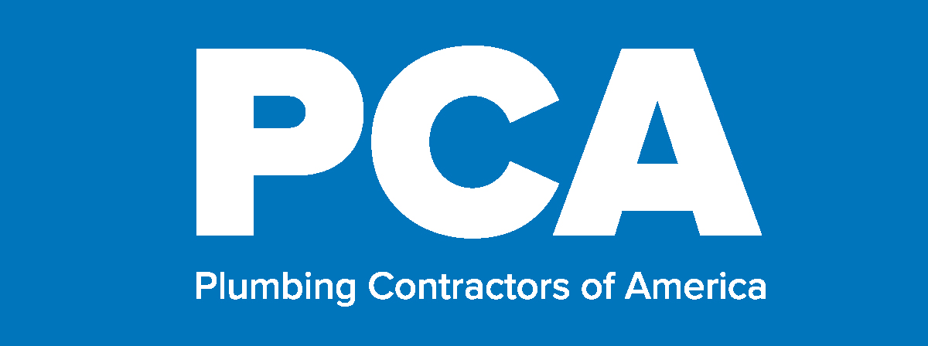
Plumbing Service Conference
September 20-21, 2021 Cleveland Marriott East, Cleveland, Ohio

Monday, September 20
1:00 PM Neptune Plumbing Service Overview
The leadership team from Neptune will provide an overview of their service operations in order to lend some context to the stations on the tour
2:00 PM Tour Buses Load for Neptune Plumbing
2:15 – 4:30 PM Tour of Neptune Plumbing Service Operations
4:45 PM Tour Buses Return to Hotel
5:00 PM Neptune Recap with Questions & Answers
5:30 - 7:00 PM Reception and Exhibit

Tuesday, September 21
7:00 AM Breakfast
8:00 AM Roundtable Number One – Stocking Your Truck and Inventory
In this session we will use roundtables to create an average set of tools that are included on a standard truck and how each company handles inventory management.
8:30 AM Residential vs Commercial
There are some key differences in each approach in terms of pricing, marketing and business strategy. This session will provide guidance to understand some of the key differences.
9:00 AM Training Roundtable – Technical Skills and Soft Skills
For many contractors, training service plumbers is a combination of improving their technical skills on a variety of products and soft skills with customers. This roundtable will discuss best practices to help teach both to your employees.
9:30 AM Large Equipment Purchases
In order to pursue some lucrative business lines, it takes heavy investment in equipment purchases. In this session we will discuss how companies can look help to develop a business model to identify and forecast business, use tax incentives to offset large expenses and train employees in the specific use of new equipment.
10:00 AM Recruiting and Maintaining Manpower Roundtable
In the final roundtable, we will discuss two of the most challenging functions of plumbing service – recruiting and keeping good service technicians. This roundtable will discuss each of those areas in order to discover ways to find new manpower as well as make sure that they are engaged and want to stay with your company.
10:30 AM Mechanical vs. Plumbing Service
While many mechanical service contractors have been able to build a service operation around mechanical work, plumbing service is a different operation. This session will focus on ways that they are different including business model, fewer areas to build maintenance contracts, and different types of emergency service.
11:00 AM Program Concludes

