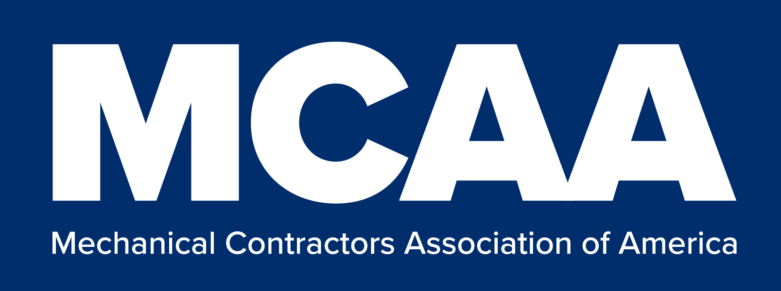
Safety Bulletin
Provided as a service of MCAA’s Safety Excellence Initiative

UPDATED 12/17/2021

Subject
OSHA Emergency Temporary Standard (ETS) on COVID-19 Vaccinations and Testing

Introduction
The Occupational Safety & Health Administration (OSHA) has issued an Emergency Temporary Standard (ETS) on COVID-19.This bulletin addresses the ETS, which was issued on November 5, 2021. The standard applies to all mechanical construction, service, and fabrication shop employers. The standard has been temporarily stayed by the Fifth Circuit. However, the stay could be temporarily lifted. This bulletin and accompanying Model COVID-19 Mandatory Vaccination Policy are available to you in case the stay is temporarily lifted, and OSHA decides to initiative enforcement.

Key Dates

November 5, 2021 – The standard became effective

January 10th, 2022 – Employers must be in compliance with all provisions in the standard, except for the testing provisions addressing employees who are not vaccinated

February 9th, 2022 – Employers must be in compliance with the testing provisions

Summary of Key Details that Affect Mechanical Industry Employers
- Employers with 100 or more employees must ensure that each of their workers is fully- vaccinated by February 9th, 2022 or tested for COVID-19 on at least a weekly basis.
- Employers are not required to pay for COVID-19 tests under the OSHA ETS but may be required to pay under other laws or collective bargaining agreements (CBAs).
- Employers must provide paid time off for employees to get vaccinated and sick leave for employees who experience side effects.
- Unvaccinated employees must wear a face mask in the workplace.
- Employers must remove from the workplace any employee who receives a positive COVID-19 test or is diagnosed with COVID-19.

For additional information about this topic or to learn more about MCAA’s Safety Excellence Initiative, contact MCAA’s Executive Director of Safety, Health, and Risk Management
Raffi Elchemmas at 301 518 2658 or raffi@mcaa.org

General Information about the OSHA COVID-19 ETS

- New Vaccination Requirement for Employers With 100 or More Employees: OSHA is issuing a COVID-19 Vaccination and Testing Emergency Temporary Standard (ETS) to require employers with 100 or more employees to:

  - Get Their Employees Vaccinated by February 9th, 2022 and Require Unvaccinated Employees to Produce a Negative Test on at Least a Weekly Basis: All covered employers must ensure that their employees have received the necessary shots to be fully vaccinated – either two doses of Pfizer or Moderna, or one dose of Johnson & Johnson – by February 9th, 2022. After that, all covered employers must ensure that any employees who have not received the necessary shots begin producing a verified negative test to their employer on at least a weekly basis, and they must remove from the workplace any employee who receives a positive COVID-19 test or is diagnosed with COVID-19 by a licensed health care provider. The ETS lays out the wide variety of tests that comply with the standard. Given that vaccines are safe, free, and the most effective way for workers to be protected from COVID-19 transmission at work, the ETS does not require employers to provide or pay for tests. Employers may be required to pay for testing because of other laws or collective bargaining agreements.

  - Pay Employees for the Time it Takes to Get Vaccinated: All covered employers are required to provide paid time off for their employees to get vaccinated and, if needed, sick leave to recover from side effects that keep them from working.

  - Ensure All Unvaccinated Employees are Masked: All covered employers must ensure that unvaccinated employees wear a face mask while in the workplace.

  - Other Requirements and Compliance Dates: Employers are subject to requirements for reporting and recordkeeping. While the testing requirement for unvaccinated workers will begin after February 9th, 2022, employers must be in compliance with all other requirements – such as providing paid-time off for employees to get vaccinated and masking for unvaccinated workers – on January 10th, 2022. The Administration is calling on all employers to step up and make these changes as quickly as possible.

Scope and Application

- The ETS applies to all employers that have a total of at least 100 employees at any time the ETS is in effect.

- This standard generally covers employers in all workplaces that are under OSHA's authority and jurisdiction, including industries as diverse as manufacturing, retail, delivery services, warehouses, meatpacking, agriculture, construction, logging, maritime, and healthcare.

- In determining the number of employees, employers must include all employees across all their U.S. locations, regardless of employees' vaccination status or where they perform their work. Part-time employees count towards the company total, but independent contractors do not.

- For a single corporate entity with multiple locations, all employees at all locations are counted for purposes of the 100-employee threshold for coverage under this ETS.

- On a typical multi-employer worksite such as a construction site, each company represented—the host employer, the general contractor, and each subcontractor—would only need to count its own employees, and the host employer and general contractor would not need to count the total number of workers at each site.

Employer Policy on Vaccination

- This ETS requires employers to adopt mandatory vaccination policies for their workplaces, with an exception for employers that instead adopt a policy allowing employees to elect to undergo regular COVID-19 testing and wear a face covering at work in lieu of vaccination.

Determination of Employee Vaccination Status

- To comply with the requirements of the standard, it is essential that employers are aware of each employee's vaccination status.

- The employer must know each employee's vaccination status to ensure that the vaccination, testing, and face covering requirements of the standard are met.

- The standard requires employers to determine the vaccination status of each employee and to maintain records of each employee's vaccination status, preserve acceptable proof of vaccination for each employee who is fully or partially vaccinated, and maintain a roster of each employee's vaccination status.

Employer Support for Employee Vaccination

- This standard requires employers to support vaccination by providing employees reasonable time, including up to four hours of paid time off, to receive each primary vaccination dose, and reasonable time and paid sick leave to recover from side effects experienced following each primary vaccination dose.

COVID–19 Testing for Employees Who Are Not Fully Vaccinated

- This ETS is also necessary to protect workers who remain unvaccinated through required regular testing, use of face coverings, and removal of infected employees from the workplace, and to protect other workers from the greater likelihood that unvaccinated workers may spread COVID-19 in the workplace.

- Routine COVID-19 testing of unvaccinated employees is necessary to identify employees with COVID-19 so they can be removed from the workplace to prevent transmission to other employees and to facilitate early medical intervention for infected employees when appropriate.

- Testing for COVID-19 can broadly be divided into two categories: diagnostic testing and screening testing:

  - The purpose of diagnostic testing is to identify current infection when a person has signs or symptoms consistent with COVID-19, or when a person is asymptomatic but has recent known or suspected exposure to SARS-CoV-2. The information provided by diagnostic testing can be used by a healthcare provider to diagnose or treat a patient.
  - The purpose of screening testing is to identify infected people who are asymptomatic and do not have known, suspected, or reported exposure to COVID-19.

Employee Notification to Employer of a Positive COVID–19 Test and Removal

- It is necessary that employees who are confirmed to have COVID-19 be removed from the workplace to prevent transmission to other employees.

- Employers must require each employee to promptly notify the employer when the employee receives a positive COVID-19 test or is diagnosed with COVID-19 by a licensed healthcare provider.

- The employer must require each employee who is COVID-19 positive to notify the employer of their COVID-19 test result or diagnosis “promptly.” For employees who are not at the workplace when they receive a positive COVID-19 test result or diagnosis, “promptly” notifying the employer means notifying the employer as soon as practicable before the employee is scheduled to start their shift or return to work. If the employee is in the workplace when they receive a positive COVID-19 test result or diagnosis of COVID-19, “promptly” notifying the employer means notifying the employer as soon as safely possible while avoiding exposing any other individuals in the workplace.

Face Coverings

- The CDC recommends that people who are not fully vaccinated wear a face covering
(e.g., a mask) in indoor public places. (CDC, July 14, 2021).

- Face coverings are simple bi-directional barriers that tend to keep droplets, and to a lesser extent airborne particulate, on the side of the filter from which they originate.

Information Provided to Employees

- Employers must provide employees with the information specified in paragraph (j), an essential part of this ETS, because it helps to ensure that employees understand both their rights and responsibilities under the ETS and their employer's policies and procedures.

- When an employer's policies or procedures change, the employer must provide any updated or supplemental information to employees.

Availability of Records

- Employers must make available, for examination and copying, the individual COVID-19 vaccine documentation and any COVID-19 test results required by the ETS for a particular employee to that employee and to anyone having written authorized consent of that employee by the end of the next business day after a request.
- Prompt employee access to this information ensures that employees have the information necessary to take an active role in their employers' efforts to prevent COVID-19 transmission in the workplace.

- This standard requires the employer to make the following information available to an employee or an employee representative on request:

  - (1) The aggregate number of fully vaccinated employees at a workplace and (2) the total number of employees at that workplace. This information must be made available to these individuals by the end of the next business day after a request. Employers will be able to utilize the roster of each employee's vaccination status and they are required to maintain this information promptly to a requester.

