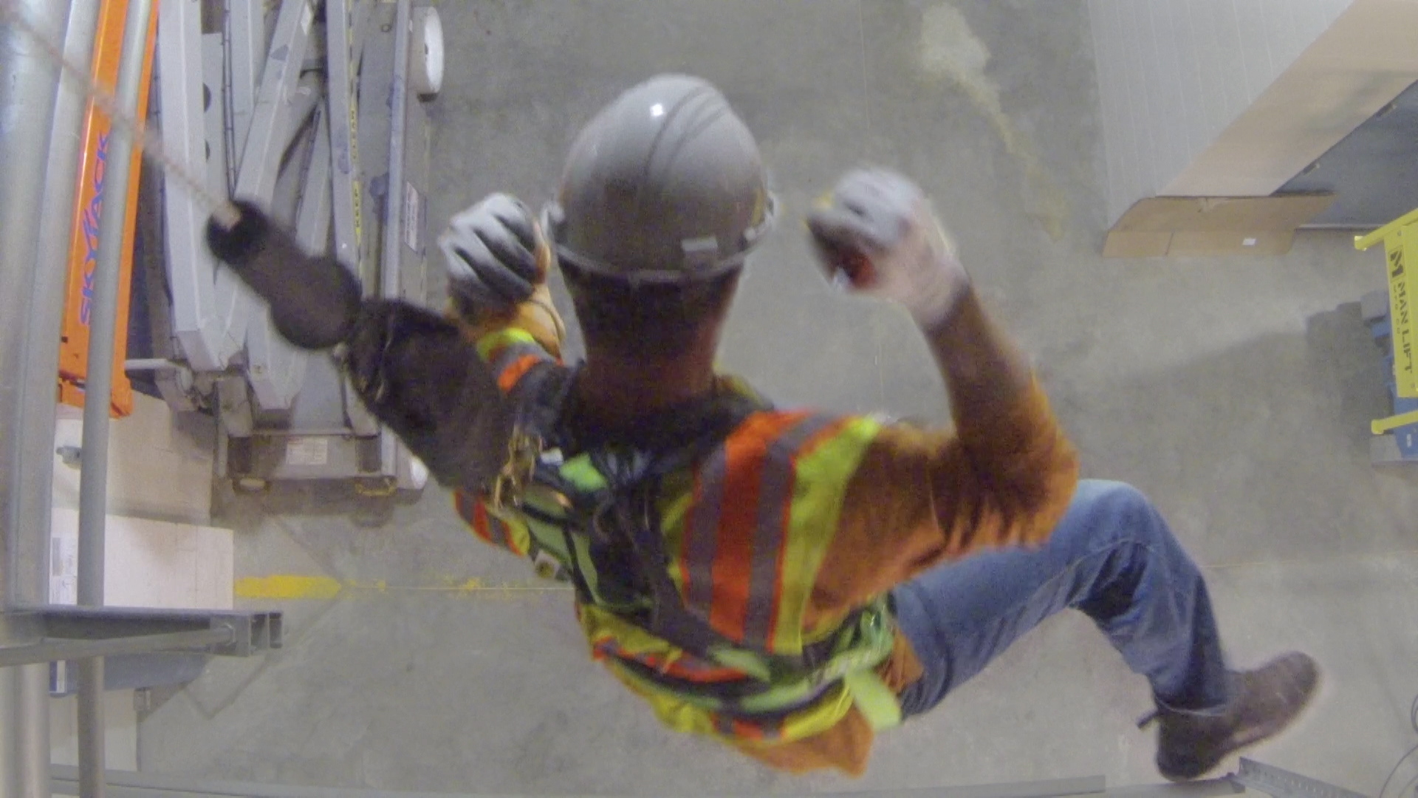

Model Fall Rescue Safety Program and Plan

Introduction

Fall rescue programs and plans are specific to rescuing workers who are suspended in fall arrest harnesses after experiencing falls from elevation. The key issue is suspension trauma. Suspension trauma occurs when a worker is suspended in a harness long enough for the harness straps to negatively affect blood flow. When blood is not circulating properly throughout the circulatory system vital organs are deprived of oxygen. Suspended workers can lose consciousness, sustain permanent organ damage, and ultimately die if suspended for a long enough period. Ten to fifteen minutes is the absolute maximum period that any worker should be left suspended. However, irreversible health effects can occur much sooner. Ideally, suspended workers should be rescued within 5 minutes.

This model program and accompanying model plan can be tailored as necessary to address various project fall arrest system applications. It will help you develop appropriate fall rescue plans, which when performed properly, will help limit the time that any worker is suspended in a fall arrest harness to less than five minutes.

This model program/plan is not intended to provide exhaustive treatment on the subject of fall rescue programs and fall rescue plans. It should not be used as a substitute for reading and interpreting federal or state OSHA regulations or any other pertinent state or local laws, rules, regulations, or standards. Further, it is not intended to provide legal advice. Employers must make independent determinations regarding the need for legal assistance.

Table of Contents
Instructions 4
Model Fall Rescue Safety Program 5
Appendix A – Model Fall Rescue Safety Plan Checklist 12
Appendix B – Model Fall Rescue Safety Plan 13

Instructions

This model program and accompanying model plan can be easily tailored to meet each company’s specific fall rescue program and planning needs. Keep in mind that the fall rescue methods selected for one project may not be viable on another. Similarly, the fall rescue methods selected for one fall rescue application may not be suitable for another fall rescue application, even on the same project. Your company will need to evaluate each independent fall rescue application and tailor the site-specific fall rescue plan(s) accordingly.

The model program portion of the document should be tailored to describe your company’s general policies regarding fall rescue. It should be reevaluated regularly and revised as needed. The model plan portion of the document should be tailored to address each specific project fall rescue planning application. All fall rescue plans should be evaluated throughout the course of the project and revised as needed.

To tailor the program/plan, carefully follow these instructions. If you have any questions that are not answered in this publication, please contact MCAA at 800-556-3653.

- Read the model program and accompanying model plan. Obvious areas that require your attention are highlighted in yellow. Before you start to tailor the model plan, be sure that you:

- Fully understand which fall rescue provisions should be covered in your plan;
- Delete everything that does not apply to your company’s specific fall rescue applications; and
- Add whatever provisions are necessary to complete the program and ensure compliance with OSHA’s Fall Protection Standard for Construction 1926 Subpart M (29 CFR 1926.502).

- Be sure to fill in all the blanks and delete all highlighted prompts.
- Personalize the program by including your company logo on the cover page.
- Implement your company’s Fall Rescue Program and accompanying Plan(s).

Company Name

Fall Rescue Safety Program

(Last Evaluated and Revised Date)

Table of Contents
Applicability 7
Purpose 7
Fall Rescue Program Management Responsibility 7
Methods of Fall Rescue 8
Use of Fall Arrest Systems 9
Qualified Fall Rescuers 10
Qualified Fall Rescuer Training Requirements 10
Fall Rescue Concept Training for All Affected Workers & Supervisors 11

Applicability

This fall rescue program, including all accompanying fall rescue plans, is applicable to all Company Name workers who could be exposed to a fall while using a fall arrest system for fall protection. It also applies to all workers and supervisors who are working where a coworker could fall while using a fall arrest system.

Purpose

The purpose of this program is to:

| Establish appropriate fall rescue policies and procedures for each fall rescue planning application where a Company Name worker could be suspended in a fall arrest harness;
| Ensure that affected workers know how to help prevent suspension trauma while suspended in a fall arrest harness;
| Ensure that affected workers know how to perform self-rescue when possible; and
| Properly prepare all affected supervisors and workers to perform or initiate appropriate, rapid fall rescue when needed.

Fall Rescue Program Management Responsibility

The project foreman on each affected project is responsible for:

| Leading implementation of Company Name fall rescue program;
| Leading identification and evaluation of each potential, applicable fall rescue application on the project;
| Selecting one or more appropriate fall rescue methods for each application based on consultation with, and recommendations from all Company Name Qualified Fall Rescuers who are or will be present on the project;
| Establishing an effective method of communication to be used by rescuers and suspended workers to communicate with each other during rescue operations;
| Establishing an appropriate fall rescue plan(s); and
| Ensuring proper implementation of the plan(s).

Methods of Fall Rescue

The fall rescue method(s) for each project will be selected from the following:

Self-Rescue

Affected workers may rescue themselves by climbing back to the level from which they fell, or by lowering themselves safely to ground level with a self-rescue device.

| When relying on a self-rescue device, the device must be properly attached to the fall arrest harness.
| Whenever self-rescue devices are being used, an effective method of two-way communication must be readily accessible to the affected worker in case injury, rescue equipment failure, or another unforeseen problem prevents self-rescue.

Ladder Rescue

An affected worker may be rescued by a coworker or Qualified Fall Rescuer using a rescue ladder.

| Where ladder rescue is the selected method of fall rescue, the ladder must be inspected before the work at elevation begins. If the ladder is in good condition, it must always be placed close to the worker(s) using the fall arrest system(s) and kept readily accessible.
| If the ladder is not in good condition, it must be taken out of service immediately in accordance with the Company Name damaged equipment policy and replaced with an acceptable ladder before work from elevation begins.
| When a rescue can be performed by placing a stable ladder underneath the suspended worker (Simple Ladder Rescue), any coworker may perform the task. More complicated ladder rescues must be performed by a Qualified Fall Rescuer.

Aerial Lift Rescue

An affected worker may be rescued by a coworker or a Qualified Fall Rescuer using an aerial lift.
| Where an aerial lift is the selected method of fall rescue, the lift must be inspected and tested before the work at elevation begins. If the lift appears to be in good condition and is working properly, it must be fully charged, placed close to the worker(s) using the fall arrest system(s) and kept readily accessible.
| If the lift is not in good condition, it must be taken out of service immediately in accordance with the Company Name damaged equipment policy and immediately replaced with an acceptable lift before work from elevation begins.
| When a rescue can be performed by raising the lift platform underneath the suspended worker (Simple Aerial Lift Rescue), any coworker who has been properly trained to use the lift may perform the rescue. More complicated aerial lift rescues must be performed by a Qualified Fall Rescuer.

Mechanically Aided Rescue

An affected worker is rescued by a Qualified Fall Rescuer using a hoist line or a rope system to raise them back to the level from which they fell or lower them down to ground level.

| Where mechanically aided rescue is the selected method of fall rescue, the rescue equipment must be inspected before the work at elevation begins. If the equipment appears to be in good condition, it must be placed close to the worker(s) using fall arrest system(s) and kept readily accessible.
| If the equipment is not in good condition, it must be taken out of service immediately in accordance with the Company Name damaged equipment policy and immediately replaced with acceptable equipment before work from elevation begins.
| Where mechanically aided rescue is the selected method of fall rescue, only Qualified Fall Rescuers may perform the rescue.

Use of Fall Arrest Systems

Any Company Name worker using a personal fall arrest system may not work alone unless a self-rescue device is attached to the fall arrest harness, the worker has received recent training on how to use the self-rescue device, the worker has demonstrated the ability to successfully use the device, and an effective form of two-way electronic communication is readily accessible to seek immediate rescue assistance if needed.

Self-Rescue Devices

An appropriate self-rescue device will be provided to each Company Name worker who must work alone while relying on a personal fall arrest system for fall protection, and to all other affected workers on a project where self-rescue is a selected method of fall rescue.

| All self-rescue devices must be properly attached to the affected workers’ personal fall arrest harnesses.

Suspension Trauma Relief Straps

All Company Name workers using fall arrest systems are required to have two suspension trauma relief straps properly attached to their fall arrest harnesses.

Qualified Fall Rescuers

Each project must have at least two Company Name employees who have received thorough, comprehensive training in all applicable fall rescue procedures, and who have demonstrated that they have the knowledge and capability to successfully perform swift fall rescues. At least one of the two Qualified Fall Rescuers must be near the affected workers and readily accessible by cell phone or two-way radio when one or more company workers is working at elevation while using a fall arrest system for fall protection.

Qualified Fall Rescuer Training Requirements

All Qualified Fall Rescuers must receive extensive training on the topics listed below before being placed in a position where they could be called upon to perform fall rescue. The training must be presented by a qualified third-party company with substantive experience and expertise on fall rescue.

| Effective communication between rescuers and suspended workers;
| Ladder rescue;
| Aerial lift rescue;
| Mechanically aided rescue;
| Recognition of symptoms of suspension trauma; and
| How to respond and administer appropriate first aid.

Fall Rescue Concept Training for All Affected Workers & Supervisors

As part of Company Name’s required fall prevention and protection training, all affected workers and supervisors will receive training on the following fall rescue subjects:

| Suspension trauma (with an emphasis on the potential health effects of being suspended in a personal fall arrest harness for an extended period);
| Proper use of suspension trauma straps to help prevent suspension trauma while a rescue is being performed. Immediately following the training, and before using a fall arrest system, each affected worker must demonstrate proper use of suspension trauma straps under direct supervision of a qualified instructor while suspended in a fall arrest harness a few feet off the ground;
| Proper inspection of relief straps and instruction on properly attaching them to the harness as part of a daily pre-use fall arrest system evaluation process;
| Other methods of staving off suspension trauma while suspended in a harness, such as lifting and holding both knees in a sitting position, pumping both legs vigorously every few minutes as if riding a bicycle, and returning to the sitting position;
| Self-rescue;
| Effective communication between rescuers and suspended workers;
| How to perform simple ladder rescue;
| How to perform simple aerial lift rescue;
| How to recognize the symptoms of suspension trauma; and
| How to respond and administer appropriate first aid.

Appendix A

Model Fall Rescue Plan Checklist

Fall Rescue Plan Checklist for: Project Name

Foreman: Foreman’s Name

Date Completed: Date

_____Qualified Fall Rescuer #1 Identified/Training Current
_____Qualified Fall Rescuer #2 Identified/Training Current
_____ A Qualified Fall Rescuer Assigned to be Readily Accessible
_____ Project Fall Rescue Applications Evaluated
_____ Fall Rescue Method(s) Determined
_____ Obstructions to Fall Rescue Removed
_____ Immediate Access to Potential Victims Established/Acceptable
_____ Anchor Points Evaluated/Acceptable Where Applicable
_____ All Affected Workers & Supervisors Properly Trained
_____ Emergency Phone Number Provided/Posted When 911 Not Available
_____ Foreman/Qualified Fall Rescuers’ Cell Numbers Provided to Workers
_____ Two Suspension Trauma Relief Straps Attached to Each Harness
_____ Self-Rescue Equipment Provided Where Applicable
_____ Self-Rescue Equipment Inspected/Properly Attached to Harness(s)
_____ Fall Rescue Equipment Present
_____ Fall Rescue Equipment Inspected
_____ Two-Way Communication System Established
_____ Two-Way Communication System Tested
_____ First Aid/AED/Emergency Rescue Equipment Readily Accessible

Appendix B

Model Fall Rescue Plan

Fall Rescue Plan for: Company Name

Project Name: Key in Project Name

Project Address: Project Address

Project Foreman: Project Foreman’s Name and Cell Phone Number

1st Qualified Fall Rescuer: Key in Rescuer’s Name and Cell Phone Number

2nd Qualified Fall Rescuer: Key in Rescuer’s Name and Cell Phone Number

Specific Location(s) of Fall Arrest Equipment Use and Application(s):

List locations where fall arrest systems will be used and describe the application(s) for each intended use

Project Fall Rescue Applications Date of Evaluation: Date

Selected Method(s) of Fall Rescue:

_____ Self-Rescue
_____ Ladder Rescue
_____ Aerial Lift Rescue
_____ Mechanically Assisted Rescue

Rescue Equipment:

All rescue equipment will be inspected by Qualified Fall Rescuer’s Name each day before it is placed into service. The following rescue equipment will be used for this fall rescue plan:

_____ Self-Rescue Device(s)
_____ Rescue Ladder
_____ Aerial Lift
_____ Hoist Line
_____ Rope System
_____ Key in Other Necessary Equipment if Applicable

Two-Way Communication:

Project Foreman’s Name will determine the two-way communication system that will be used for this plan. When either a two-way radio or cell phone system is selected, the system will be tested before work at elevation begins and again when the affected worker(s) reach elevation. If the communication system proves to be ineffective, it will be replaced with an effective system before the work at elevation begins.

_____ Voice
_____ Two-Way Radio
_____ Cell Phone
_____ Other

Fall Rescue Checklist:

Before the work at elevation begins Project Foreman’s Name will complete a project fall rescue checklist (see Appendix A) to ensure that all critical elements of the fall rescue plan have been properly addressed. Work at elevation will not begin until Project Foreman’s Name confirms that the fall rescue plan(s) is in place and ready to be implemented if necessary.

Rescue Procedures:

The first worker or supervisor to observe a suspended victim will immediately assess whether the victim has been injured, and whether he is able to perform self-rescue.

If the victim is unable to perform self-rescue the responder will perform simple rescue whenever doing so is in accordance with Company Name fall rescue plan(s).

When the rescue must be performed by a Qualified Fall Rescuer, the responder will immediately contact the designated Qualified Fall Rescuer and state the exact location of the victim. While the Qualified Fall Rescuer is on the way to the scene, the responder will identify and move the rescue equipment to the location of the victim.

If the victim is injured, the responder will call 911 for emergency assistance immediately after contacting the Qualified Fall Rescuer.

The responder will inform Project Foreman’s Name about the incident as soon as the victim has been rescued or is no longer involved in the rescue.

Mechanical Contractors Association of America, Inc.
1385 Piccard Drive Rockville MD 20850 T 301 869 5800 F 301 990 9690 MCAA.ORG

